Waterwatch
Waterbug and platypus adaptations (Years 5–6)
Lesson sequence
Victorian Curriculum F–10 links:
Levels 5 and 6
Science
Science Understanding
Biological sciences
Living things have structural features and adaptations that help them to survive in their environment (VCSSU074)
The growth and survival of living things are affected by the physical conditions of their environment (VCSSU075)
Geography
Geographical Knowledge
Factors that shape places and influence interconnections
Influence of people, including the influence of Aboriginal and Torres Strait Islander peoples, on the environmental characteristics of Australian places (VCGGK094)
Environmental and human influences on the location and characteristics of places and the management of spaces within them (VCGGK096)

Introduction

Waterbugs (aquatic macroinvertebrates) are an important but mostly invisible element of our local waterways. They are a crucial food source for other animals and the biodiversity of waterbugs is used as an indicator of waterway health.

In this lesson sequence, students explore the diversity of waterbugs in their local waterway and some of the adaptations that enable them to survive and (hopefully) thrive in their habitat. It also showcases the platypus adaptations that make the platypus such a special resident of our waterways.

Activity 1: Identifying waterbugs
Students identify the waterbugs in a sample and draw conclusions about the health of the waterway based on the sensitivities of the waterbugs found. This activity is most effective when conducted as part of a field excursion. If this is not possible it can be run as an in-class activity.

Activity 2: Waterbug adaptations
Students explore the different ways in which waterbugs obtain oxygen.

Activity 3: Platypus adaptations
Students use technology or craft materials to explore platypus anatomy and how they are adapted to their habitat.

Activity 4: Where are the waterbugs?
Students explore a scenario about a river then play a game to discover why the waterbugs are disappearing.

Activity 1: Identifying waterbugs

Students identify the waterbugs in a sample and draw conclusions about the health of the waterway from the sensitivities of the waterbugs found.

If you are conducting this activity in the classroom, a waterbug sample must be collected early on the morning of the activity. Students then view the waterbugs in the classroom. Refer to the Waterbug identification in the classroom (page 5) of the Teacher guide: Running a waterbug session with students. Amend the activity steps below as required. Additional classroom viewing equipment could include magnifying lamps with LED lights, digital microscopes (10X magnification) and laptops.

Equipment
For the teacher:
Teacher guide: Running a waterbug session with students <https://www.melbournewater.com.au/media/8431/download>
Waterbug sampling equipment: net, pole, bucket and gloves
Scope: Waterbugs video [3:13] <www.youtube.com/watch?v=ufUrn0_mmGo>
Interactive whiteboard or data projector (if available)
An A3 laminated hardcopy or digital version of What waterbugs can you find? poster <www.melbournewater.com.au/media/6751/download> or the online guide A beginners guide to waterbug identification <www.melbournewater.com.au/media/117/download> for class display
A copy of the Dive into the underwater world with the Waterbug Census infographic from the Waterbug Census: discovering the world of waterbugs brochure <www.melbournewater.com.au/media/442/download> for class display

Images of the waterway sampling site.
For each group:

As per the equipment list in the Teacher guide: Running a waterbug session with students (page 7).

Optional: A copy of the relevant Know your river booklets
Know your river - Werribee River
Know your river - Yarra River
Know your river - Maribyrnong River
Know your river - Dandenong Creek
Know your river - Bass River

The booklets provide valuable teacher background information about the history, geography and wildlife of the Werribee River, Yarra River, Maribyrnong River, Dandenong Creek and Bass River.

Preparation
Refer to pages 2–6 of the Teacher guide: Running a waterbug session with students. This guide provides detailed instructions about how to conduct a field excursion and how to collect waterbugs for an in-class waterbug identification activity. Topics include: acknowledgement of the Aboriginal connection to the local area, what are waterbugs, why they are important, how they can be used to assess waterway health, safety aspects, data sheets, detailed instructions for sampling, sorting, identifying and analysing waterbug data and information about waterway hygiene. Ensure that you comply with your school safety requirements.
Take photographs of the sampling site or gather some images of local waterways that can be used to explain waterway terminology e.g. riparian vegetation; verge; banks; riffles, pools or runs; aquatic plants; snags; stones, sand or silt substrates (Habitat assessment – Resource 2 of the Teacher guide: Running a waterbug session with students).
Prior to the excursion, explain the context of the activity in the classroom (Activity steps 1–4) below.

Activity steps
Citizen scientists
- Before the excursion, discuss some volunteer work students might have participated in at school or at home. Some examples include friends of parks groups, working bees, community gardens, tree planting, beach rubbish collection, meals on wheels, fundraising, marshalling or setting up events.
- Discuss the term ‘citizen scientist’. Citizen scientist programs such as the Waterbug Census, the Frog Census and PlatypusSPOT are programs that invite community members to participate in monitoring and recording species to increase scientific knowledge.
- Ask students to imagine they are citizen scientists and that their work will contribute to important research on the health of a local waterway.
Display the Scope: Waterbugs video and discuss collecting and recording waterbugs as a citizen science activity. This video explains how waterbugs can be used to monitor the levels of pollution in waterways. It also covers waterbug adaptations including how they breathe and hunt.
- Show images of the local waterway. Ask: Do you know where this is? Have you been there? Explain how the waterbug sample is collected. Use the terms: riparian vegetation; verge; banks; riffles, pools or runs; aquatic plants; snags; stones, sand or silt substrates and explain their meaning. A drawing, diagram or an enlarged, laminated photograph of a waterway may be useful. Alternatively, digital photographs of a local waterway could be used to explain these terms.
Identifying waterbugs, recording and analysing data in the field
- On the excursion, follow the Waterbug identification and data collection activity instructions in the Teacher guide: Running a waterbug session with students (pages 8– 9). Explain how to look for waterbugs in the sample and how to identify them. Students record the data on the Waterbugs data form and calculate the SIGNAL score for their sample. Collate and display the group signal scores and discuss the results using the focus questions on page 9.
Taking action
- Review the excursion results and conclusions about the health of the waterway.
- Ask students what actions they can take to help protect their waterways? Examples include:
- Increased nutrients affect water quality. Therefore you need to pick up dog poo when walking your dog as it enters waterways via stormwater.
- Make sure litter goes in the bin as litter can enter waterways via stormwater.
- If you like to see a range of animals around your local waterway, do your bit to limit water pollution. For instance, don’t wash the car on a hard surface. The soapy suds can flow into the stormwater drain and then into the local creek.
- Look after the small waterbugs and you are looking after the larger animals. Lots of animals depend on waterbugs for their food.
- Plant trees to increase shade and dissolved oxygen levels in the water. Cool water has a higher level of dissolved oxygen than warm water.

Extension activities
1. Students form small groups to discuss and respond to a range of scenarios about the health of a waterway. The What waterbugs can you find? poster, A beginners guide to waterbug identification, Know your river booklets and The waterbug app are all useful reference resources for this activity.
The scenarios (see examples below) can be written or typed onto a card for each group. They could also be displayed on a whiteboard or placed around the room on large pieces of sticky note poster paper. Each group can add their conclusions.
Possible scenarios:
A freshwater ecologist found large numbers of different waterbugs including mayfly nymphs, caddis fly larvae and dragonfly nymphs. What might this tell you about the water quality? (Excellent water quality, healthy waterway)
A freshwater ecologist found large numbers of several waterbugs such as mosquito larvae, water boatmen and water striders. What might this tell you about the water quality? (Somewhat polluted and disturbed waterway)
The vegetation along a creek bank is removed and the water turbidity (cloudiness) increases. What might happen to waterbugs with gills? Why? (They may disappear as they find it hard to get oxygen from turbid water)
What larger animals do you expect to find if the variety of waterbugs in a sample is large or low? (Large variety of waterbugs – wide variety of frogs, fish, platypus) (Low variety of waterbugs – low variety of frogs, fish)
Students respond to scenarios and can use specific waterways (such as those rivers detailed in the Know your river booklets) as examples.
To conclude, students share their knowledge about what makes a waterway healthy. Discuss why it is important to have healthy waterways. What additional benefits are there when the health of a waterway is improved?
2. Team up with another Year 5–6 class at a different school (via River Detectives if you are participating in the program) and compare the data you collected with the data they collected. Discuss similarities and differences in your findings. Exchange photos of your waterways to compare and contrast.

Key messages
- Our waterways support a diverse range of plant and animal life, including native fish, frogs and platypuses. They are worth looking after.
- Everyone can help improve local rivers and creeks by reducing stormwater pollution – simple things like picking up after your dog, binning rubbish and fixing oil leaks in your car can reduce the impacts.

Useful resources
Waterwatch Program
<www.melbournewater.com.au/community-and-education/waterwatch-program>
Melbourne Water’s Waterwatch Program supports people to get involved in exploring and protecting their local waterways through the Frog Census, Platypus Census, Waterbug Census or becoming a water quality testing volunteer. In addition, schools can apply to participate in the River Detectives program.
The program also provides keen citizen scientists with training and tools to become involved in monitoring the health of our waterways. Data collected contributes to scientific research, management planning and on ground actions that improve the health of our waterways.
You can become involved by joining a Waterwatch group, attending one of their events, using the citizen science apps or downloading resources to learn more about your local waterway.
Waterbug Census
<www.melbournewater.com.au/community-and-education/waterwatch-program/waterbug-census>
Waterbugs (macroinvertebrates) are very useful biological indicators and students can join other citizen scientists in monitoring waterbugs in Melbourne Water’s Waterbug Census. This data is important for ongoing research and water management.
River Detectives
<www.riverdetectives.net.au/>
The River Detectives sustainability program supports educators in schools and youth community programs to explore their local waterways with students. Some activities include monitoring waterways for waterbugs, collecting samples, recording findings and compiling data.
As part of the program, your group will receive a water monitoring kit (on loan), invitations to training sessions and access to more activities, resources and an interactive data recording portal.
Spaces in the River Detectives program are limited so apply now.
Healthy Waterways, Waterways Program Handbook
<www.melbournewater.com.au/media/425/download>
Complete Waterways Training document, including safety information, macroinvertebrate identification and data forms.
Waterbug Census: discovering the world of waterbugs brochure
<www.melbournewater.com.au/media/442/download>
This brochure provides readily accessible graphics to introduce waterbugs to students. It includes a map of the Waterbug Census sites across Melbourne, a diagram of the main types of waterbugs including their feeding strategies and a ‘waterbug profile’ diagram.
A beginners guide to waterbug identification
<www.melbournewater.com.au/media/117/download>
This Melbourne Water guide assists students to identify the more common waterbugs found in the Melbourne area. It also provides information about the taxonomy of the waterbugs, their anatomy, distribution, diet and sensitivity to pollution.
Australian freshwater invertebrates interactive guide <www.mdfrc.org.au/bugguide/resources/howtouse.htm>
This interactive guide to the identification and ecology of Australian freshwater invertebrates is designed to provide ecological and taxonomic information to enable community groups, students and scientists to readily identify inland aquatic invertebrates.
Waterbugs higher level key
From River Detectives <www.riverdetectives.net.au/wp-content/uploads/2018/08/Waterbugs-ALT-higher-level-key.pdf>
This key provides a useful introduction to both waterbug identification and dichotomous keys.
The waterbug app
<thewaterbugapp.com/>
The waterbug app is a very useful tool for identifying and uploading waterbug data. Students can identify waterbugs using a dichotomous key with engaging cartoon diagrams to explain structural features.
River health and monitoring
<www.melbournewater.com.au/water/health-and-monitoring/river-health-and-monitoring>
Melbourne Water monitors rivers and creeks so they know if their condition changes or if the improvement programs need adjusting. Learn how Melbourne Water assess river health and view current data.
Other information includes: indicators of river health, the health of Melbourne’s waterways, and key waterway values.
Know your river booklets
Know your river - Werribee River
Know your river - Yarra River
Know your river - Maribyrnong River
Know your river - Dandenong Creek
Know your river - Bass River
The booklets provide valuable teacher background information about the history, geography and wildlife of the Werribee River, Yarra River, Maribyrnong River, Dandenong Creek and Bass River.
Making macroinvertebrates
<www.riverdetectives.net.au/wp-content/uploads/2017/03/RD-Manual-Making-macros-Teachers-Section-APPROVED.pdf>
In this activity from the North Central Waterwatch program, students use art materials to design and construct a macroinvertebrate creature.
Melbourne’s Living Museum of the West Inc.
<https://www.livingmuseum.org.au/>
Melbourne’s Living Museum of the West is a community Museum which actively involves the people of Melbourne’s West and others in documenting, preserving and interpreting the richness and depth of the region’s social, industrial and environmental history.
Melbourne Water – Melbourne’s Water Story
<http://www.waterstory.melbournewater.com.au/>
Melbourne’s Water Story is an interactive timeline that explores significant milestones that have helped shape the city of Melbourne.

Activity 2: Waterbug adaptations
Students explore the different ways in which waterbugs obtain oxygen.

Equipment
Scope: Waterbugs video [3:13] <www.youtube.com/watch?v=ufUrn0_mmGo>
How waterbugs get their oxygen cards (Resource 1)
Construction and/or craft materials
Optional: Augmented reality apps such as HP Reveal or AR Makr and iPad or tablet

Activity steps

Waterbugs and oxygen
- To review Activity 1, show the Scope: Waterbugs video. Discuss the terms used in Activity 1 such as: riparian vegetation; verge; riffle; aquatic plants; slow-flowing, deep pools; muddy, sandy or rocky bottom. Ask students to suggest which of the terms could describe the area that is featured in the video. How did Priya (the narrator) sample for waterbugs? How did some of the waterbugs breathe underwater?
- Discuss the structures that waterbugs use to obtain oxygen and how they function. Use the How waterbugs get their oxygen cards (Resource 1) to explain the different ways they obtain their oxygen. Highlight the structures of each waterbug and its particular behaviours. Ask students to mime how these waterbugs breathe.
- Using A beginners guide to waterbug identification and The waterbug app, students list other facts about the waterbugs, including their diet, habitat and predators.
- Students choose a waterbug and make it using plasticine or other craft/woodwork materials. They need to emphasise the structure that enables the waterbugs to obtain oxygen.
- Students display and/or share their digital or physical creations with the rest of the class.
Optional: Using an app that allows you to create Augmented Reality scenes, such as AR Makr (iPad only) or HP Reveal, students choose a waterbug and build it. Again, students need to emphasise the structure that enables the waterbugs to obtain oxygen.

Teacher background
Waterbugs with gills
Species such as mayfly nymphs have respiratory gills on their abdomen. They generally live in flowing water and use the flow of water over their gills to ventilate them.
Carrying a water bubble underwater
Some species such as water boatmen breathe air when they are at the surface of the water. They are able to breathe underwater by carrying an air bubble trapped by the hairs that line their body.
A snorkel-type structure
With the aid of a breathing tube in their tails, mosquito larvae obtain oxygen from the air. This is similar to using a snorkel.
Oxygen diffuses through the skin
Freshwater worms get their oxygen from water. The oxygen passes through their body wall in a process called diffusion.

Breathing air
A water strider is able to stand on the water surface using the water-surface tension and take in oxygen from the air.

Useful resources
See Activity 1.

Activity 3: Platypus adaptations
Students explore the form and function of platypus anatomy to discover how they are adapted to their habitat.

Equipment

Introducing platypusSPOT app video [1:32] <platypusspot.org/> or
<www.youtube.com/watch?v=EMiPAmo2nZk>
Construction and/or craft materials such as:
Plasticine, playdough or clay
icy pole sticks, toothpicks or chopsticks
clean empty containers
thumb tacks
wire
glue, sticky tape or blu-tack
feathers
foil
Drawing materials and sketch paper
Optional: Augmented reality apps such as HP Reveal or AR Makr and iPad or tablet

Activity steps
Platypus in our waterways
- Discuss with students some of the other animals that live in and around our waterways. For example, platypus, frogs, birds, snakes and lizards.
- Watch the Introducing platypusSPOT app video to introduce students to the platypus and its habitat. Platypus are key indicators of the health of our waterways. If platypus are present, there is a good chance the waterway is healthy.
Adaptations
- Ask students to name the parts of a platypus, focussing on its unique features. Platypus appear to have features of many different creatures (a bill like a duck, fur like a wombat, claws like a koala, venom like a snake, lay eggs like a bird). Platypus have evolved over hundreds of thousands of years to suit their waterway environment. What purpose do these features serve?
4. Students research the anatomy of the platypus and discuss how these features would help their survival. Some examples are:
Webbed feet to help them swim.
Waterproof fur insulates them against the cold.
Hind legs are used mainly for steering.
Tail acts as a rudder when swimming and aid the animal when diving.
Small eyes but excellent eyesight to detect movement on the riverbank.
No visible ears but excellent hearing with sensitivity to lower frequency.
Electro-reception to detect prey and determine its location.
Catch their prey and carry to the surface in cheek pouches (used for storage).
No teeth but instead have small, horny pads which they use to hold and grind their prey.
Males have spurs on their hind legs that produce powerful venom. This can inflict painful wounds in humans and can kill animals such as dogs that attack them.
Lay eggs in burrows away from predators.

5. Students then research another Australian animal of their choice to discover its features.

Create a creature

- Using craft materials or pencils and paper, students take aspects of the platypus and other Australian animals and create their own animal. Aspects of other Australian animals can be added into their own creature. For example, their creature might have a pouch like a wombat, it might climb like a koala and it might have fangs like a snake. Their imagination is the limit! Also think about where the animal would live and what features it would need to survive there.
- Students share the animal creations in small groups and explain why they have included particular features. How is the animal adapted to its habitat? What benefit will its features have in that environment?
Optional: Using an app that allows you to create Augmented Reality scenes, such as AR Makr (iPad only) or HP Reveal, students build a creature that is made up of parts of other animals. The scene could include the creature’s habitat so they would again need to focus on what the creature needs to survive there.

Extension
Students create a display of the weird and wonderful creatures, using photographs or sketches of the creatures’ habitats as the backdrop.

Excursion
Explore a local waterway to look for platypus using the PlatypusSPOT app.

Useful resources
Platypus returns to our rivers [3:31]
<www.youtube.com/watch?time_continue=102&v=7H3HvsASrXg>
This video explains the importance of environmental flows to ensuring platypus populations in waterways.
Platypus: Environmental value
<yoursay.melbournewater.com.au/healthy-waterways/platypus>
This web page explains where platypus live around Melbourne, their ecology and the key threat to their populations.
Platypus adaptations
<australianmuseum.net.au/learn/animals/mammals/platypus/>
This web page provides detailed information about platypus adaptations and ecology.
Platypus biology
<platypusspot.org/learning-centre/platypus-biology>
<dpipwe.tas.gov.au/wildlife-management/fauna-of-tasmania/mammals/echidnas-and-platypus/platypus/platypus-in-tasmania> (includes a recording of a platypus growling)
These web pages also provide information about platypus biology.

Activity 4: Where are the waterbugs?
In this activity, students explore a scenario and discover why waterbugs are disappearing.

Equipment
The Melbourne River scenario (based on life in a fictional Melbourne river) (Resource 2)
Macroinvertebrate mayhem game (Resource 3)
The waterbug app <https://thewaterbugapp.com/>

Activity steps
The situation
- As a class, read the scenario The Melbourne River scenario (Resource 4). Ask students to listen or read carefully and emphasise or take note when a platypus and the different species of waterbugs are mentioned.
Discuss:
- What happened to make the mayfly nymphs and stonefly nymphs leave?
- What happened to make the dragonfly larvae and damselfly larvae leave?
- Where did the pond snails come from? (Introduced species)
- What sorts of waterbugs were in the river when the factories were polluting the river?
- What happened to make the platypus disappear?
- What happened to bring the sensitive species back?
- How might we bring the platypus back?
- Outline the rules for the Macroinvertebrate mayhem game (Resource 3). This game gives students an understanding of how hard it is for platypus and certain species of waterbugs to survive in a polluted waterway.
- Discuss why some of the species were more easily caught than others.
Further activity
Using The waterbug app, discover the waterbugs in your local waterway as a school group or family outing.

Key messages
- Our waterways are home for a range of animals including waterbugs.
- Waterbugs are an important food source for platypus, fish and frogs. They are very sensitive to changes in the environment and are a good indicator of waterway health.
- Everyone can help improve our local rivers and creeks by reducing stormwater pollution and litter – simple things like picking up after your dog, binning rubbish and fixing oil leaks in your car can reduce the impacts.

Useful resources
See Activity 1.

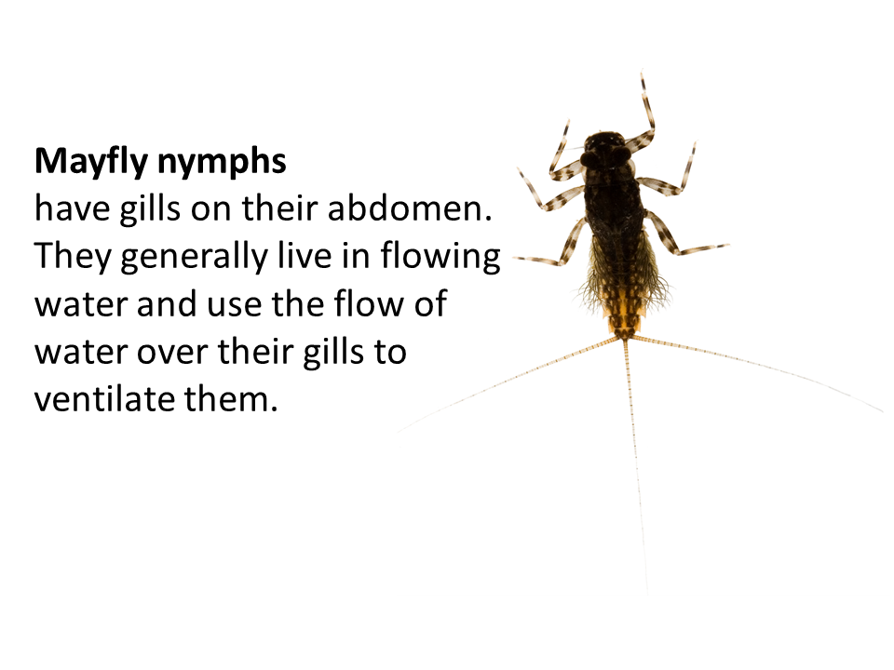
Resource 1 How waterbugs get their oxygen

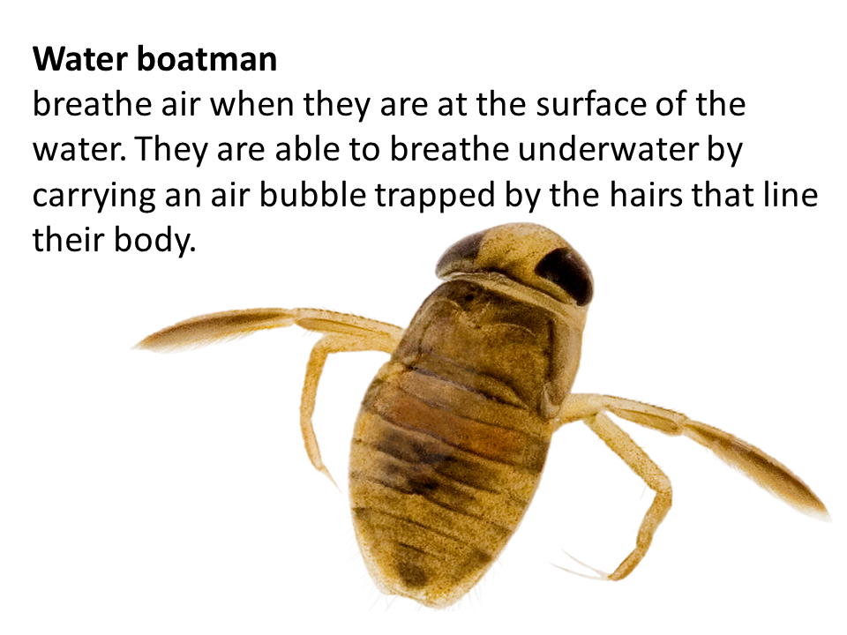

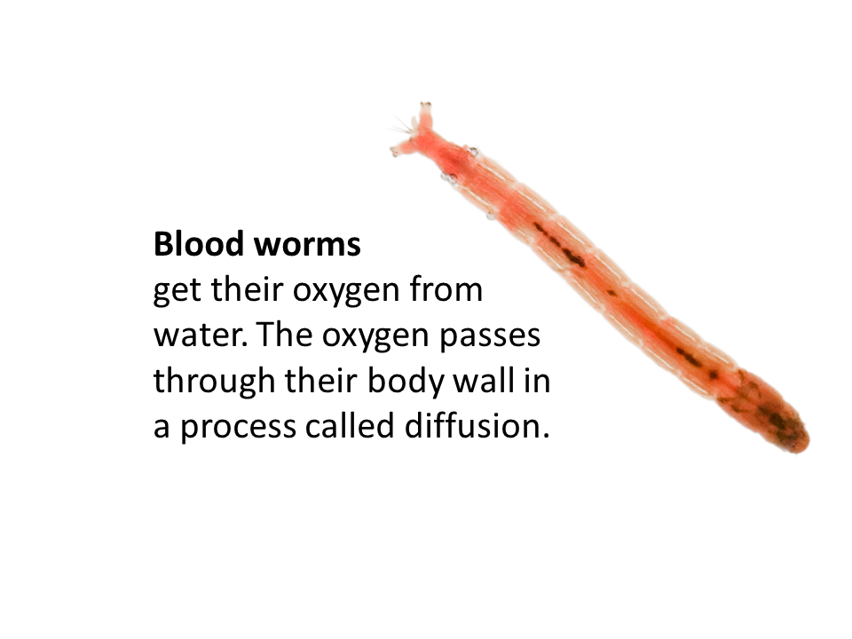

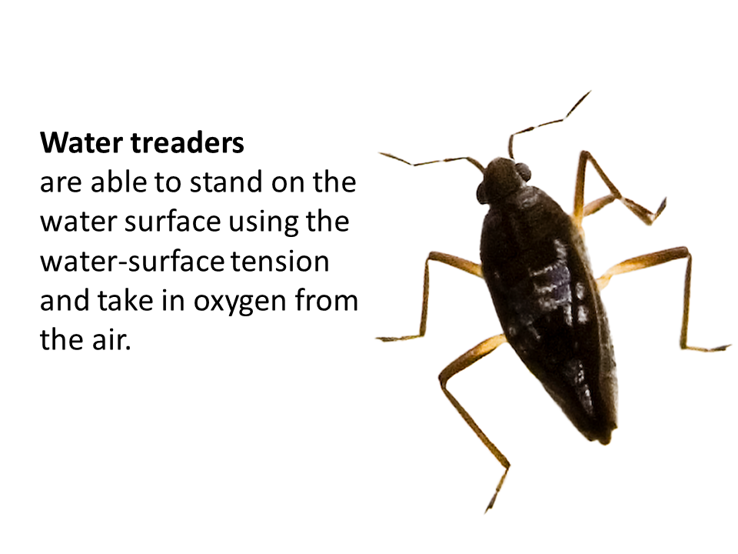

Resource 2 The Melbourne River scenario

This story describes the history of a fictional river that starts on the western outskirts of Melbourne and explains the changes that occurred over time in a number of rivers and urban streams in this area.
Using historical knowledge, you could tailor the scenario for your local river to demonstrate the impacts that urbanisation has on the health of your river.

The Melbourne River starts in the hills and flows through farmland, outer suburbs then in through the inner suburbs and finally through the city and out to Port Phillip Bay where it meets the ocean.

Every day for more than 40,000 years, families of the Wurundjeri People came to the river to collect water to drink. The river was cool and fresh. It was of great importance to the Wurundjeri People and was used for food, medicine, construction material, drinking water and travelling by canoe.

Edible plants grew near the river flats, big game such as kangaroos and emus were found on the great basalt plains. Smaller animals like echidna, possum, lizards and water birds lived nearby. They saw platypus, fish and eels and listened to the frogs. They collected water from the top layer of the river so it was clean to drink. When they looked closely at the river surface and into the water, reeds and mud, they found caddisfly larvae, dragonfly larvae, damselfly larvae, stonefly nymphs, mayfly nymphs, water boatmen, backswimmers, amphipods and leeches.

In the mid-1830s, Europeans arrived in the Melbourne area and thought it was a good place to settle. More and more people followed and that was the beginning of the city we now call Melbourne.

By 1840, farmers settled much of the land next to the Melbourne River. It provided a reliable source of water for the sheep but livestock (such as sheep and cattle) caused erosion along the banks of the river.

During the 1850s, people came from other places in Australian and from overseas to find gold. They travelled from Melbourne to the goldfields in Ballarat and Bendigo and camped along the river on their way. They tried their luck at gold panning in the Melbourne River, which stirred up the sediment in the water.

The children liked to scoop up the creatures in the water to see what they could find. They saw lots of backswimmers, amphipods, leeches, mosquito larvae and dragonflies but it was a surprise to find a caddisfly larvae. They played platypus ‘I spy’ and were thrilled when they saw the head of a platypus.

Market gardeners drew water from the river to irrigate their fruit and vegetables. They sold their produce to the diggers travelling to the goldfields. They noticed pond snails (like the ones in England) in the water they pumped. They also noticed mosquito larvae and dragonflies.

During the 1860s and 1870s, factories were built: they included abattoirs, tanneries, soap works, candle works, acid works and a wool washer. All of the wastewater (and left-over fat, blood and scraps) was dumped into the river. More than 2,000 tons of blood and offal was poured into the river each year. The river often flooded and homes and businesses went under water.

People also poured household sewage (wastewater from the bath, toilet and buckets) into the river. This was before we had a network of sewerage pipes. During this time, the river became highly polluted and only the very tolerant waterbugs like flatworms and backswimmers were found. Platypus could not live here anymore. The river earned the nickname ‘Stinkopolis’ because it smelt terrible!

The area became more and more built up during the early 1900s. Native vegetation was cleared to make way for recreational facilities. People enjoyed fishing and picnicking along cleaner parts of the river. They explored the waterways but only saw platypus occasionally. Following a Royal Commission into the public health crisis, the Melbourne and Metropolitan Board of Works was formed. The Royal Commission recognised the relationship between health risks and water supply, particularly in relation to cholera and typhoid.

Twenty years later, urban planners and engineers reshaped the waterways to control flooding. They built bluestone banks and diverted floodwater. A wetland next to the river was filled in with soil to make way for houses. The water in the river wasn’t safe to drink and, when children did play in the water, they noticed that even the flatworms and backswimmers had disappeared. The river suffered severe environmental degradation caused by human activities. Platypus had to find somewhere else to live.

Life on the river continued like this for some time until the 1970s when people started to realise how important the river was. They started to think and care more about their natural environment. After years of damage to the river, the Environment Protection Act was passed. Waste from industry now had to be treated before being released into the environment, ensuring that our waterways are protected for future generations.

In the 1980s and 90s, the factories and warehouses were converted into apartments, housing, cafes and restaurants. People liked to walk and jog along the river paths. They took family bike rides. Teachers took their students to the river when they studied the environment. Most people talked about seeing a platypus but it had been many years since platypus had lived here. Every so often, someone saw a dragonfly or damselfly.

Now, we have community groups, councils and government agencies who all look after the river. Friends groups and Melbourne Water create healthy waterways with help from the community. The area was replanted. Native vegetation is considered to be very important because it stabilises the eroded banks and provides habitat for the animals that rely on the river for food. Traditional Owners work with these people to help bring life back to the river.
The people who live along the river feel very lucky to call it home. They participate in rubbish clean-up days and tree planting days. They help Melbourne Water to identify frogs around the river. They pick up their dog’s poo when they’re out walking. They understand that hair ties and rubber bands can be fatal to platypuses so they collect these when they find them.

A local school group participates in the River Detectives program and tests the water quality, including identifying the types of macroinvertebrates that live in the river. They have found caddisfly larvae, dragonfly larvae, damselfly larvae, stonefly nymphs, mayfly nymphs, water boatmen, backswimmers, amphipods and leeches. They also use an app called PlatypusSPOT to see if they can find platypus in the river. They haven’t found one yet but they will keep looking.

Resource 3 Macroinvertebrate mayhem game

Students form groups and play a game that simulates changes in a stream when an environmental stressor, such as a pollutant, is introduced. This can be played on a large oval, basketball court or other open area.

Groups:
- Platypus
- Caddisfly larvae
- Dragonfly larvae and damselfly larvae
- Stonefly nymph
- Mayfly nymph
- Flatworms and backswimmers
- Amphipods and leeches

One or two students:
- Act as an environmental stressor (e.g. pollution, sedimentation, sewage or factory waste)

- Divide the class (apart from the one or two students acting as the environmental stressors) into seven groups. Each group represents one of the above macroinvertebrate species, or a platypus.
- Create name stickers for each group.
- Inform students that some macroinvertebrates have hindrances to crossing the field (see table below). These obstacles symbolise very sensitive organisms’ intolerance to pollutants. Ask the students with these labels to practice their motions.
- Assemble the macroinvertebrate groups at one end of the oval and the environmental stressors in the middle of the oval. When a round starts, macroinvertebrates will move toward the opposite end of the oval and the stressor will try to tag them. To “survive”, the macroinvertebrates must reach the opposite end of the oval without being tagged by the environmental stressor. The environmental stressor can try to tag any of the macroinvertebrates, but will find it easier to catch those with hindered movements.
- Begin the first round of the game. Once tagged, macroinvertebrates must go to the sidelines. They can remain there or join the other more tolerant species groups (and put on a new sticker name tag, e.g. flatworms and backswimmers).
- The round ends when all of the macroinvertebrates have either been tagged or have reached the opposite end of the playing field.
- Complete two more rounds, with all tagged players rejoining the macroinvertebrates who successfully survived the previous round.
- Record, or simply draw students’ attention to, the number of tolerant species who “survived” compared to the number of sensitive species who “survived”.

Organism | Hindrance | Rationale for hindrance
Caddisfly | Must place both feet together and hop across the field, stopping to gasp for breath every five hops. | Caddisflies are intolerant of low oxygen levels.  They build cases and attach themselves to rocks for protection and stabilisation.
Stonefly | Must do a push up every ten steps. | When oxygen levels drop, stoneflies undulate their abdomens to increase the flow of water over their bodies.
Mayfly | Must flap arms and spin in circles when crossing the oval. | Mayflies often increase oxygen absorption by moving their gills.
Platypus | Must bend down and touch the ground with one hand every five steps. | Platypus constantly forage for food and require an abundant supply of macroinvertebrates.

Victorian Curriculum and Assessment Authority (VCAA) <victoriancurriculum.vcaa.vic.edu.au/> Accessed 8 January 2019.
Used with permission, Cascadia Conservation District www.kidsinthecreek.com/wp-content/uploads/2012/06/macroinvertebrate_mayhem.pdf Accessed 4 May 2019

